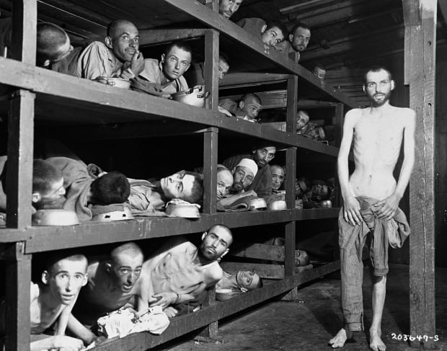

visual Literacy Nathan Aspinall
Holocaust men: personally i think this picture is a good visual representation because it shows a lot an can have multiple outcomes and how someone can see it differently.
This is the visual posted by one of my classmates that I am interested in responding to for a Visual Reflection.

When you are asked to view a visual (as on your diploma exam) consider the following:
- What is the main message/theme being communicated through the visual?
- What elements of the visual impact your response the most?
Now go back to the discussion topic INTERACTIVITY #1 - VISUAL LITERACY and choose a visual posted by one of your classmates that you are interested in responding to for a Visual Reflection. In a well-developed response of 3-5 paragraphs, answer the following question based on your choice:
What ideas and impressions does the photograph suggest to you? Consider the context, and develop your response by referring to the photograph.
In your writing, you may respond personally, critically, and/or creatively.
You must:
- Select a prose form that is appropriate to the ideas you wish to express and that will enable you to effectively communicate to the reader.
- Consider how you can create a strong unifying effect.
Take some time to review some of Alberta Education's suggestions for writing the Visual Reflection and review the list of prose options to help make your choice.
Suggestions for Writing the Visual Reflection Assignment
Consider all the details of the visual text(s). Then, ask yourself what details are most important to you, have the greatest effect on you, or are the most noticeable for you, such as contrasts or similarities of various details. Consider any introductory comments, caption, or footnotes that accompany the text(s); this information may help you in your understanding of the text(s) and the context. The details that stand out for you should work together to enable you to focus on what you think are the ideas and impressions suggested but the visual text(s). This focus will help you to establish and sustain your unifying effect, which you will make clear by statement or implication.
Make judgements and assumptions about the visual texts to aid you in your explorations of ideas and your reflections on impressions. For example, your judgements and assumptions may be about the emotions, attitudes, intended actions, situations, and thoughts presented in or inspired by the text(s). From these responses, you will develop ideas, reflect on them, and make choices about how you will present your insights.
An important point to remember is that there is no “correct” answer or approach to the Visual Reflection Assignment. When choosing the prose form (not poetry) that will best communicate your ideas and impressions, consider the ideas and support that will allow you to compose the most effectively.
Regardless of the prose form you choose, make sure that you support your ideas with adequate and appropriate details(s) from the text(s) and/or the context you have chosen to use. If, for example, you choose a narrative form, you may not want to directly discuss the visual text(s); more likely, you will indirectly allude to a certain aspect of the visual text or to your responses evoked by it.
Organize your writing in a clear, focused manner. Have a plan for presenting your ideas and impressions. Some prose forms, of course, have their unique characteristics, which you would likely adopt. In a letter or personal journal form, for example, you would likely use the first person (“I,””we”); whereas in a newspaper article or expository composition, you may choose to use the third person (“he,””she,””they”).
Possibly the most important advice we can give you is to have confidence in your ideas and impressions. Trusting your ideas, impressions, and feelings will enhance the creation of your writing voice. Use your rime efficiently. If your response is clear, focused, organized, and well supported, you will be successful.
This is the Alberta Education’s suggestions
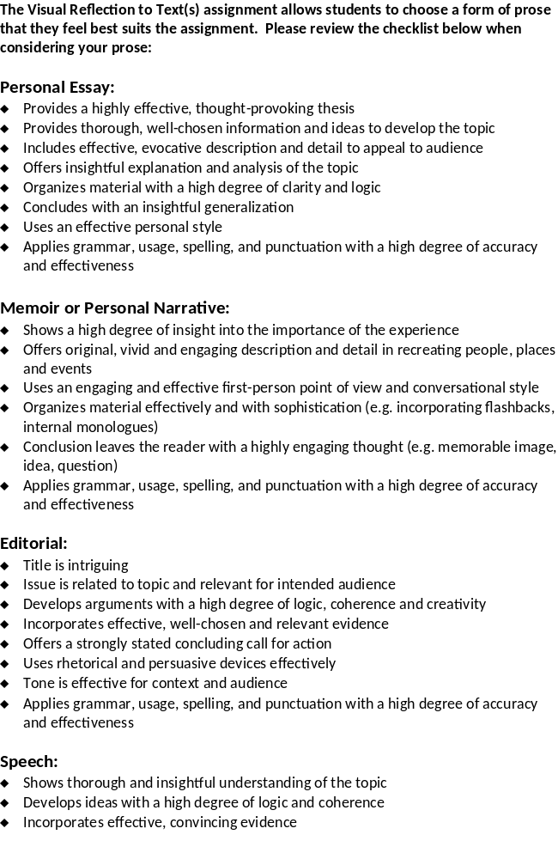
This is the list of prose options

